# How to access the Model properties in Controller:

The best and real time practice is to use the “Html.BeginForm” html helper method.

Ex:

@using (Html.BeginForm("Insert", "ContactUs", FormMethod.Post))

Action Method Controller Name

Steps:

**View changes:**

If we want to post the values to the controller action method ( in other way, post the data to the database), first we have to use the “Html.BeginForm” with in the view as shown below.

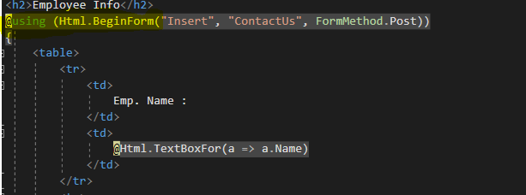

Parameters for this helper method are

1. Action Method
2. Controller Name
3. FormMethod (Get or Post)

**Controller Changes:**

The action method code looks like below

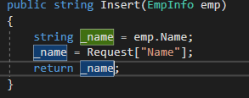

* We need to pass the model as the parameter to the action method.
* Two ways to get the data from the view to controller ;
  + From the model object
    - String _name=emp.Name
  + From the Request object
    - Request[“Name”]